Software Requirements Specification
for
<CAR WAREHOUSING MANAGEMENT SYSTEM>
Version 2.0 approved
Prepared by <K230907 ZUBAIR AHMED, K230516 USMAN KHALID, K230668 MUJTABA KHAN>
<FAST-NUCES KARACHI>
<3-DECEMEBER-2025>
Table of Contents
Table of Contents ii
Revision History ii
1. Introduction 1
1.1 Purpose 1
1.2 Document Conventions 1
1.3 Intended Audience and Reading Suggestions 1
1.4 Product Scope 1
1.5 References 1
2. Overall Description 2
2.1 Product Perspective 2
2.2 Product Functions 2
2.3 User Classes and Characteristics 2
2.4 Operating Environment 2
2.5 Design and Implementation Constraints 2
2.6 User Documentation 2
2.7 Assumptions and Dependencies 3
3. External Interface Requirements 3
3.1 User Interfaces 3
3.2 Hardware Interfaces 3
3.3 Software Interfaces 3
3.4 Communications Interfaces 3
4. System Features 4
4.1 System Feature 1 4
4.2 System Feature 2 (and so on) 4
5. Other Nonfunctional Requirements 4
5.1 Performance Requirements 4
5.2 Safety Requirements 5
5.3 Security Requirements 5
5.4 Software Quality Attributes 5
5.5 Business Rules 5
6. Other Requirements 5
Appendix A: Glossary 5
Appendix B: Analysis Models 5
Appendix C: To Be Determined List 6

Revision History
Name | Date | Reason For Changes | Version
K230907 ZUBAIR AHMED | December 1, 2025 | Initial Document Creation | 1.0
K230907 ZUBAIR AHMED | December 3, 2025 | Adding & Developing Project 15 Domain Features | 2.0

Introduction

Purpose
<This Software Requirements Specification (SRS) document describes the complete requirements for the Car Dealership Management System. The system is a comprehensive web-based solution designed to manage all aspects of a car dealership's operations, including inventory management, sales processing, customer relationships, and administrative functions. This document covers the entire system scope and serves as the authoritative reference for development, testing, and project management.>

Document Conventions
< Bold text indicates key terms and system features
Italic text highlights important notes and constraints
Monospace text represents code, database terms, or technical references
Priority Levels:
High (H): Critical for system operation
Medium (M): Important but not critical
Low (L): Nice to have features
- Requirement identifiers follow the format: REQ-[SECTION]-[NUMBER]
>

Intended Audience and Reading Suggestions
< This document is intended for:
- Developers: For implementation and coding (Sections 3, 4, 5)
- Project Managers: For planning and tracking (Sections 1, 2, 6)
- Testers: For test case creation (Sections 4, 5)
- End Users: For understanding system capabilities (Sections 2, 4)
- Stakeholders: For project approval (Sections 1, 2, 4)

Reading Suggestions:
- New readers start with Sections 1 and 2
- Technical team should focus on Sections 3 and 4
- Project managers should review Sections 2 and 5
>

Product Scope
<The Car Dealership Management System is a web-based application that automates the complete operations of a car dealership. The system manages vehicle inventory, processes sales orders, maintains customer relationships, and provides administrative controls. It replaces manual processes with digital automation, improving efficiency, reducing errors, and enhancing customer experience. The system aligns with business goals of increasing sales, improving inventory turnover, and strengthening customer loyalty.>

References
< IEEE Standard 830-1998: IEEE Recommended Practice for Software Requirements Specifications
Project Vision Document: "Car Dealership Digital Transformation Initiative"
Database Design Document: "MySQL Schema Specification v1.0"
UI/UX Design Guide: "Impel Cars Interface Standards v2.1"
Security Policy: "Data Protection and Privacy Standards 2025"
>

Overall Description

Product Perspective
<The Car Dealership Management System is a new, self-contained product designed to replace multiple disconnected systems currently used by the dealership. It integrates inventory management, sales processing, customer management, and reporting into a single unified platform. The system operates independently but can interface with external systems in the future. It represents a complete digital transformation of dealership operations. >

Product Functions
< The system provides the following major functions:
- Vehicle Inventory Management: Complete CRUD operations for brands, models, and specifications
- Sales Order Processing: End-to-end order management with automated pricing
- Customer Relationship Management: User profiles, reviews, and test drive bookings
- Administrative Controls: User management, data maintenance, and system configuration
- Search and Filtering: Advanced vehicle discovery with multiple criteria
- Reporting and Analytics: Basic reporting on sales, inventory, and customer data
>

User Classes and Characteristics
< Administrators: Full system access, technical expertise, daily users
- Sales Managers: Inventory and sales management, moderate technical skills
- Sales Representatives: Order processing and customer interaction, basic technical skills
- Inventory Managers: Stock management and procurement, moderate technical skills
- Customers: Vehicle browsing and purchasing, varying technical skills
- System Administrators: Technical maintenance and support, advanced technical skills
>

Operating Environment
< Hardware Platform: Standard x86-64 server architecture, 8GB RAM minimum, 100GB storage
- Operating System: Linux (Ubuntu 20.04+), Windows Server 2019+, macOS Server
- Web Server: Apache 2.4+ or Nginx 1.18+
- Database: MySQL 8.0+ or MariaDB 10.5+
- Client Requirements: Modern web browser (Chrome 90+, Firefox 88+, Safari 14+)
- Network: HTTPS support, minimum 10Mbps connection
>

Design and Implementation Constraints
< Corporate Policies: Must comply with data protection regulations (GDPR/PDPA)
- Technology Stack: PHP 8.0+, MySQL, HTML5, CSS3, JavaScript, Bootstrap 5
- Database Constraints: Third Normal Form compliance, foreign key relationships
- Security Requirements: Password encryption, SQL injection prevention, session management
- Performance Requirements: Page load time < 3 seconds, concurrent user support > 100
- Development Standards: PSR-12 coding standards, MVC architecture pattern
- Browser Compatibility: Must support last 2 versions of major browsers
>

User Documentation
< The following documentation will be provided:
- User Manual: Complete guide for end users (PDF and online format)
- Installation Guide: Step-by-step server deployment instructions
>

Assumptions and Dependencies
< Assumptions:
- Users have basic computer literacy
- Internet connectivity is available
- Hardware meets minimum specifications
- Database server is properly configured
- PHP extensions are correctly installed
Dependencies:
- PHP 8.0+ runtime environment
- MySQL/MariaDB database server
- Web server with PHP support
- SSL certificate for secure connections
- Regular browser updates from users
>

External Interface Requirements

User Interfaces
< The system provides a web-based interface with the following characteristics:
- Responsive Design: Adapts to desktop, tablet, and mobile screens
- Consistent Navigation: Standard header, footer, and menu structure
- Color Scheme: Professional blue and white theme with accent colors
- Typography: Clear, readable fonts with appropriate sizing
- Forms: Consistent validation, error messages, and help text
- Images: Optimized vehicle and logo images with preview capabilities
- Accessibility: WCAG 2.1 Level AA compliance for accessibility
- Browser Compatibility: Works on Chrome, Firefox, Safari, Edge

Sample Interface Components:
- Dashboard with key metrics
- Data tables with pagination and sorting
- Form wizards for complex operations
- Modal dialogs for confirmations
- Image upload with preview
- Search filters with multiple criteria
>

Hardware Interfaces
< Server Hardware: Standard server with network interface
- Storage: Local or network-attached storage for file uploads
- Printers: Support for network printers for order receipts (future enhancement)
- Barcode Scanners: Potential integration for inventory management (future)
- Mobile Devices: Responsive interface for tablets and smartphones
>

Software Interfaces
< Database: MySQL 8.0+ or MySQL
- Web Server: Apache 2.4+ with mod_php
- PHP Extensions: Required: mysqli, gd, mbstring, json,
- JavaScript Libraries: Bootstrap 5, jQuery 3.6+, DataTables plugin
- File System: Local file system for uploads with proper permissions
- Operating System: Standard POSIX-compliant file operations
>

Communications Interfaces
< HTTP/HTTPS: Primary protocol for web communication
- Database Connection: TCP/IP to MySQL server on port 3306
- File Upload: Multipart form data via HTTP POST
- Session Management: PHP sessions with cookie-based tracking
- Security: SSL/TLS for encrypted communications
- AJAX: Asynchronous JavaScript for dynamic updates
- REST API: Potential for future mobile app integration
>

System Features
<This template illustrates organizing the functional requirements for the product by system features, the major services provided by the product. You may prefer to organize this section by use case, mode of operation, user class, object class, functional hierarchy, or combinations of these, whatever makes the most logical sense for your product.>

Vehicle Inventory Management
<Don’t really say “System Feature 1.” State the feature name in just a few words.>
4.1.1 Description and Priority
<Priority: High
Comprehensive management of all vehicle-related data including brands, models, specifications, and stock levels. This feature forms the core inventory database of the dealership. >
4.1.2 Stimulus/Response Sequences
< 1. User adds new brand → System validates data, saves to database, uploads logo
- User adds new vehicle model → System validates, saves with images, updates stock
- User edits specifications → System updates technical details, maintains history
- User searches inventory → System filters and displays matching vehicles
- User checks stock → System displays current availability and quantities
>
4.1.3 Functional Requirements
<Itemize the detailed functional requirements associated with this feature. These are the software capabilities that must be present in order for the user to carry out the services provided by the feature, or to execute the use case. Include how the product should respond to anticipated error conditions or invalid inputs. Requirements should be concise, complete, unambiguous, verifiable, and necessary. Use “TBD” as a placeholder to indicate when necessary information is not yet available.>

<Each requirement should be uniquely identified with a sequence number or a meaningful tag of some kind.>

REQ-INV-1: The system shall allow creation of new car brands with name, logo, founding year, country, CEO, and affiliations.
REQ-INV-2: The system shall support upload of brand logos with validation for image type and size.
REQ-INV-3: The system shall allow management of vehicle models with complete details including name, brand, type, price, year, manufacture place, and stock.
REQ-INV-4: The system shall support upload of front and rear vehicle images with preview.
REQ-INV-5: The system shall track stock levels with real-time quantity updates.
REQ-INV-6: The system shall manage vehicle specifications including engine type, fuel type, transmission, and technical details.
REQ-INV-7: The system shall categorize vehicles by type (sedan, SUV, hypercar, etc.).
REQ-INV-8: The system shall track brand affiliations and partnerships.
REQ-INV-9: The system shall provide manufacturer details including headquarters, subsidiaries, and financial data.
REQ-INV-10: The system shall mark trending vehicles based on order activity.

Sales & Order Management

Description and Priority

Priority: High
Complete order processing system from creation to fulfillment, including automated pricing, stock validation, and status tracking.

4.2.2 Stimulus/Response Sequences

- Customer places order → System validates stock, calculates price, creates order
- Admin updates order status → System updates order, sends notifications (future)
- System checks stock → Prevents orders exceeding available quantity
- Order completes → System updates trending status based on recent activity
- User views order history → System displays all orders with details and status

4.2.3 Functional Requirements

REQ-ORD-1: The system shall allow creation of new orders with user, vehicle model, quantity, and delivery details.
REQ-ORD-2: The system shall automatically calculate total price based on vehicle price and quantity.
REQ-ORD-3: The system shall validate stock availability before order confirmation.
REQ-ORD-4: The system shall track order status (Pending, Processing, Shipped, Delivered, Cancelled).
REQ-ORD-5: The system shall maintain complete order history with dates and changes.
REQ-ORD-6: The system shall prevent overbooking through database triggers.
REQ-ORD-7: The system shall automatically update vehicle trending status based on order frequency.
REQ-ORD-8: The system shall provide order search and filtering capabilities.
REQ-ORD-9: The system shall generate order summaries and receipts.
REQ-ORD-10: The system shall update inventory quantities automatically upon order completion.

Customer Relationship Management

Description and Priority

Priority: Medium
Management of customer interactions including profiles, reviews, ratings, and test drive bookings.

Stimulus/Response Sequences

- Customer registers → System creates account, sends confirmation (future)
- Customer writes review → System saves rating and comment with timestamp
- Customer books test drive → System schedules appointment, checks availability
- User views reviews → System displays ratings and comments for vehicles
- Admin manages bookings → System updates test drive status and details

Functional Requirements

REQ-CRM-1: The system shall allow customer registration with profile information.
REQ-CRM-2: The system shall support customer reviews with 1-5 star ratings and comments.
REQ-CRM-3: The system shall allow test drive bookings with preferred dates and times.
REQ-CRM-4: The system shall track test drive status (Pending, Confirmed, Completed, Cancelled).
REQ-CRM-5: The system shall display average ratings for each vehicle model.
REQ-CRM-6: The system shall maintain customer profiles with contact information and history.
REQ-CRM-7: The system shall support profile image uploads for customers.
REQ-CRM-8: The system shall provide customer search and management for administrators.
REQ-CRM-9: The system shall track customer order history and preferences.
REQ-CRM-10: The system shall ensure data privacy and protection for customer information.

User Management System

Description and Priority
Priority: High
Secure authentication and authorization system with role-based access control and profile management.

Stimulus/Response Sequences
- User logs in → System validates credentials, creates session
- User registers → System creates account, encrypts password
- Admin creates user → System sets permissions, sends credentials
- User updates profile → System validates and saves changes
- User logs out → System destroys session, clears data

Functional Requirements
REQ-USER-1: The system shall provide secure login with username/email and password.
REQ-USER-2: The system shall encrypt passwords using bcrypt algorithm.
REQ-USER-3: The system shall maintain user sessions with timeout protection.
REQ-USER-4: The system shall support role-based access control (Admin, Manager, Sales, Customer).
REQ-USER-5: The system shall allow user profile management with personal information.
REQ-USER-6: The system shall support profile image uploads with validation.
REQ-USER-7: The system shall provide secure logout functionality.
REQ-USER-8: The system shall prevent unauthorized access to restricted areas.
REQ-USER-9: The system shall track user activity and login history.
REQ-USER-10: The system shall allow administrators to manage all user accounts.

Administrative Functions

Description and Priority

Priority: Medium
System configuration, data management, and administrative controls for system operation.

Stimulus/Response Sequences

- Admin adds data → System validates and stores in database
- Admin edits record → System updates with proper validation
- Admin deletes data → System confirms, removes record, maintains referential integrity
- Admin searches data → System provides filtering and sorting options
- System exports data → Generates reports in standard formats (future)

Functional Requirements

REQ-ADMIN-1: The system shall provide complete CRUD operations for all data entities.
REQ-ADMIN-2: The system shall validate all data inputs before processing.
REQ-ADMIN-3: The system shall provide search and filtering across all data tables.
REQ-ADMIN-4: The system shall support bulk operations for data management.
REQ-ADMIN-5: The system shall maintain data integrity through foreign key constraints.
REQ-ADMIN-6: The system shall provide data backup and recovery procedures.
REQ-ADMIN-7: The system shall support system configuration and settings management.
REQ-ADMIN-8: The system shall provide audit logging for critical operations.
REQ-ADMIN-9: The system shall generate basic reports and statistics.
REQ-ADMIN-10: The system shall support data import/export capabilities (future enhancement).

Other Nonfunctional Requirements

Performance Requirements
< Response Time: Page load < 3 seconds under normal load
- Concurrent Users: Support for 100+ simultaneous users
- Database Queries: Complex queries complete within 5 seconds
- Image Uploads: Process within 10 seconds for standard images
- Availability: 99.5% uptime during business hours
- Scalability: Support for 10,000+ vehicle records, 50,000+ orders
- Memory Usage: Efficient memory utilization with proper garbage collection
- Network Performance: Optimized for standard broadband connections
>

Safety Requirements
< Data Safety: Regular automated backups to prevent data loss
- Error Handling: Graceful error recovery without data corruption
- Input Validation: Protection against malicious or erroneous inputs
- System Monitoring: Health checks and alerting for critical failures
- Recovery Procedures: Documented recovery processes for system failures
- Data Integrity: Transaction support to maintain consistent data state
>

Security Requirements
< Authentication: Secure login with encrypted passwords
- Authorization: Role-based access control for all functions
- Session Security: Secure session management with timeout
- Data Encryption: SSL/TLS for all data transmission
- SQL Injection Prevention: Prepared statements and input validation
- File Upload Security: Validation of uploaded file types and sizes
- Access Logs: Tracking of login attempts and security events
- Password Policy: Strong password requirements (future enhancement)
- Data Privacy: Protection of customer personal information
>

Software Quality Attributes
< Usability: Intuitive interface with minimal training required
- Reliability: Consistent operation with minimal downtime
- Maintainability: Clean, documented code with modular design
- Portability: Compatibility across standard web servers and databases
- Testability: Support for automated testing and quality assurance
- Scalability: Architecture supporting future growth and expansion
- Performance: Efficient algorithms and database optimization
- Accessibility: Compliance with web accessibility standards
- Documentation: Complete and up-to-date technical documentation
>

Business Rules
< Order Processing: Orders cannot exceed available stock quantities
- Pricing: Total price = Vehicle price × Quantity
- Trending Vehicles: Models with 5+ orders in 30 days marked as trending
- User Roles: Different permission levels for different user types
- Data Validation: All required fields must be completed before submission
- Image Requirements: Vehicle images must be in standard web formats
- Date Validation: Future dates not allowed for order dates
- Stock Management: Quantity cannot go below zero
- User Registration: Email addresses must be unique
- Review Ratings: Must be between 1 and 5 stars
>

Other Requirements
< 6.1 Database Requirements
- Normalization: Third Normal Form compliance
- Indexing: Strategic indexes for performance optimization
- Backup: Daily automated database backups
- Integrity: Foreign key constraints and cascading operations
- Transactions: Support for ACID-compliant transactions
- Storage: Efficient storage of images and binary data
- Recovery: Point-in-time recovery capability
- Security: Database user accounts with least privilege access

6.2 Internationalization Requirements
- Character Encoding: UTF-8 support for multilingual content
- Date Formats: Support for multiple regional date formats
- Currency: Support for multiple currency symbols (future enhancement)
- Language: Potential for multi-language interface (future enhancement)
- Timezone: Server-side timezone management

6.3 Legal and Compliance Requirements
- Data Protection: Compliance with relevant data protection laws
- Privacy Policy: Clear privacy policy for user data
- Terms of Service: Legal terms for system usage
- Audit Requirements: Support for financial and operational audits
- Record Keeping: Proper maintenance of business records
- Export Controls: Compliance with international trade regulations

6.4 Reuse Objectives
- Code Reuse: Modular design for component reuse
- Database Reuse: Standardized schema for future projects
- Template Reuse: Common UI templates and components
- Library Reuse: Use of standard, maintained libraries
- Pattern Reuse: Consistent design patterns throughout system
>

Appendix A: Glossary
<Define all the terms necessary to properly interpret the SRS, including acronyms and abbreviations. You may wish to build a separate glossary that spans multiple projects or the entire organization and just include terms specific to a single project in each SRS.>

TERM | DEFINITION
ACID | Atomicity, Consistency, Isolation, Durability - database transaction properties
AJAX | Asynchronous JavaScript and XML - technique for asynchronous web requests
API | Application Programming Interface - set of rules for software communication
CRUD | Create, Read, Update, Delete - basic database operations
CSS | Cascading Style Sheets - language for styling web pages
ERD | Entity Relationship Diagram - visual representation of database structure
FTP | File Transfer Protocol - standard network protocol for file transfers
GDPR | General Data Protection Regulation - EU data privacy law
GUI | Graphical User Interface - visual interface for software
HTML | HyperText Markup Language - standard language for web pages
HTTP | Hypertext Transfer Protocol - foundation of web data communication
HTTPS | HTTP Secure - encrypted version of HTTP
JSON | JavaScript Object Notation - lightweight data interchange format
MVC | Model-View-Controller - software design pattern
MySQL | Open-source relational database management system
PDO | PHP Data Objects - database access layer for PHP
PDPA | Personal Data Protection Act - data privacy law in various countries
PHP | Hypertext Preprocessor - server-side scripting language
REST | Representational State Transfer - architectural style for web services
SRS | Software Requirements Specification - this document type
SSL | Secure Sockets Layer - encryption protocol for internet security
SQL | Structured Query Language - language for managing databases
TLS | Transport Layer Security - successor to SSL for encryption
UI | User Interface - space where human-computer interaction occurs
UX | User Experience - overall experience of using a product
WCAG | Web Content Accessibility Guidelines - accessibility standards
XAMPP | Cross-platform web server solution stack
XSS | Cross-Site Scripting - security vulnerability in web applications

Appendix B: Analysis Models
<Optionally, include any pertinent analysis models, such as data flow diagrams, class diagrams, state-transition diagrams, or entity-relationship diagrams.
ENTITY RELATIONSHIP DIAGRAM
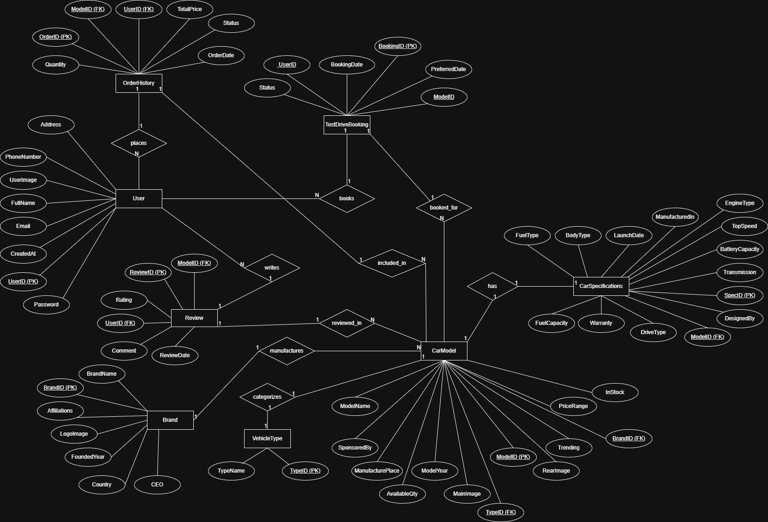

CLASS DIAGRAM

ACTIVITY DIAGRAM 1
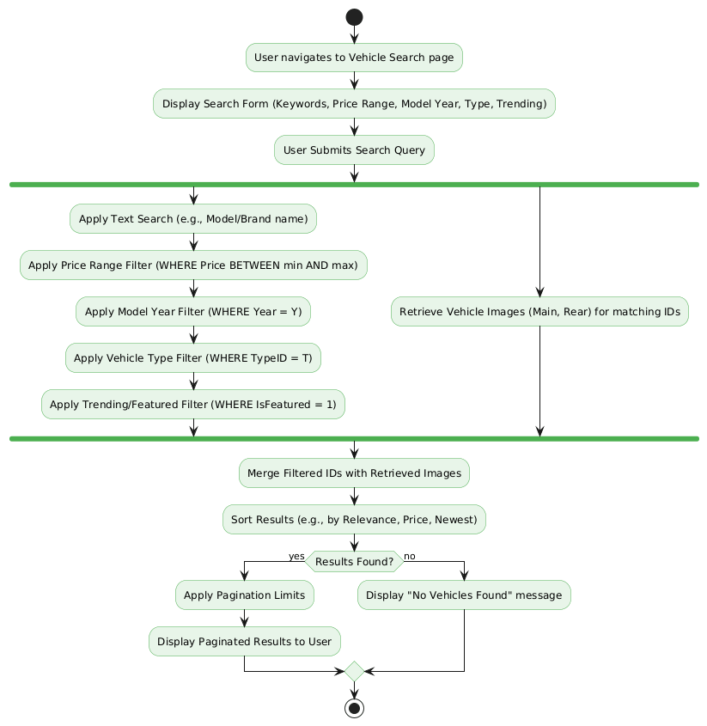

ACTIVITY DIAGRAM 2
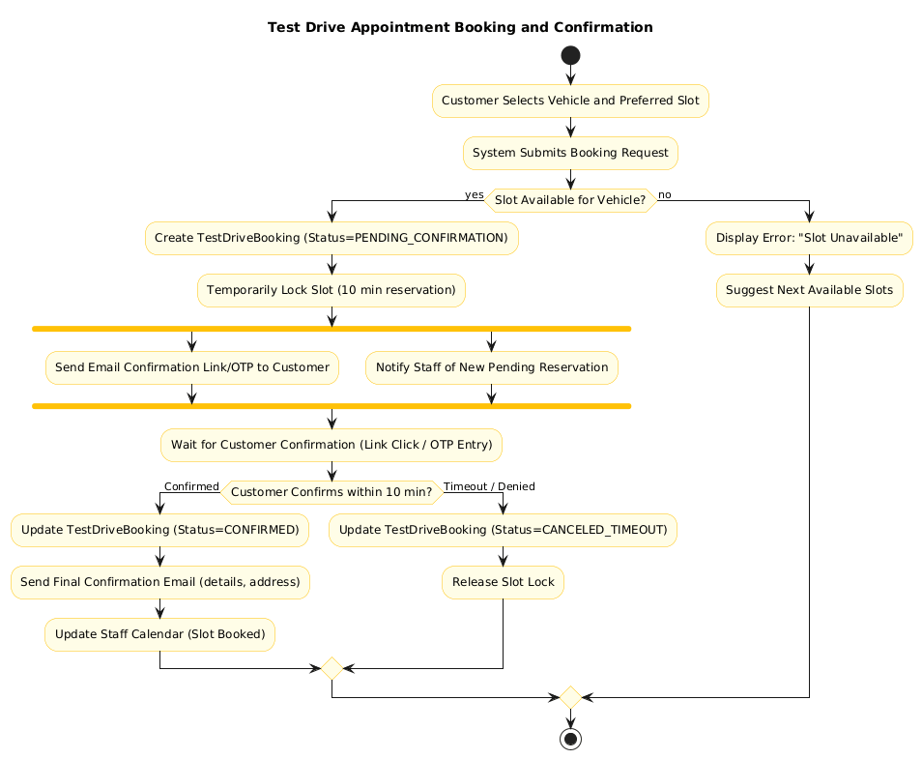

ACTIVITY DIAGRAM 3
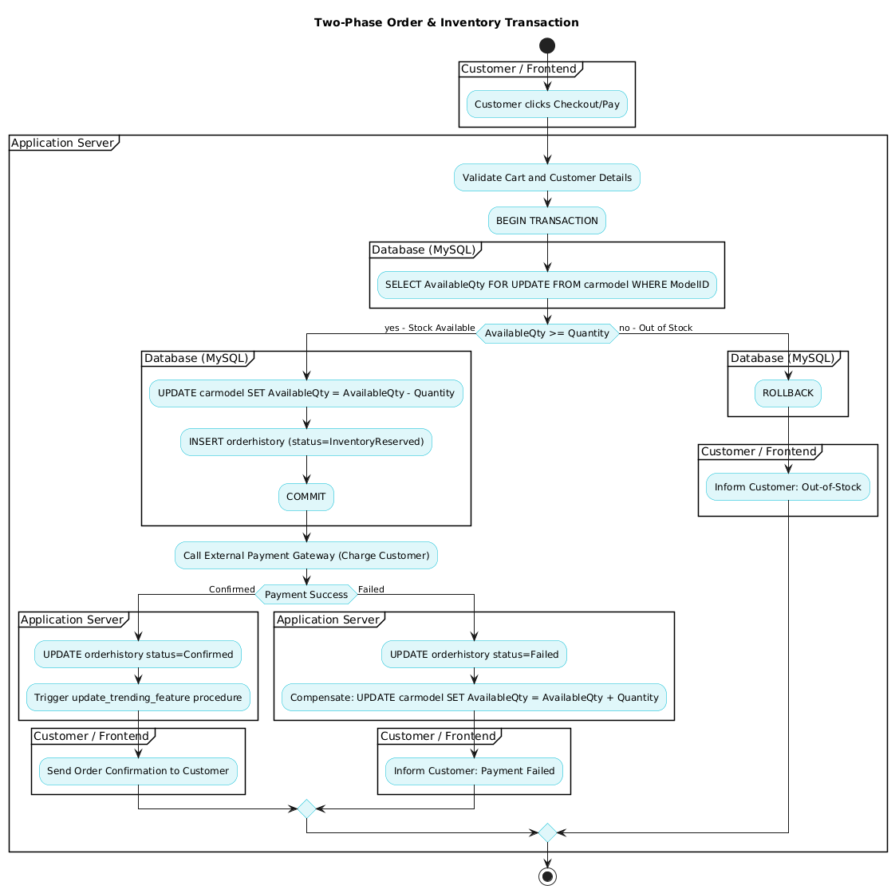

ACTIVITY DIAGRAM 4
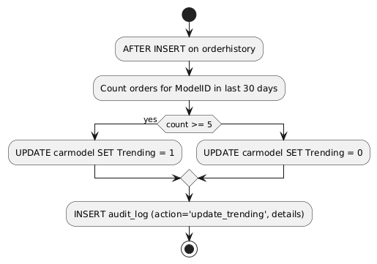

COLLABORATION DIAGRAM 1

COLLABORATION DIAGRAM 2

COLLABORATION DIAGRAM 3

COLLABORATION DIAGRAM 4

COLLABORATION DIAGRAM 5

COLLABORATION DIAGRAM 6

COLLABORATION DIAGRAM 7

COLLABORATION DIAGRAM 8

COMPONENT DIAGRAM

DEPLOYMENT DIAGRAM

SEQUENCE DIAGRAM

STATE MACHINE DIAGRAM

USE-CASE DIAGRAM

TIMING DIAGRAM

>
Appendix C: To Be Determined List
<Collect a numbered list of the TBD (to be determined) references that remain in the SRS so they can be tracked to closure.>

